DEPARTMENT OF **MECHANICAL**



# ENGINEERING

## College

I studied in Visayas State University from year 2021 until now. I can see how my earlier education laid the foundation for where I am today. The problem-solving mindset I developed through coding, the technical skills I gained from welding and drawing, and the teamwork experiences from senior high school have all come together to help me thrive in my current studies. College has introduced me to more advanced concepts in engineering, and while the challenges have been greater, I've learned to approach them with resilience and a desire to continuously learn.

**Achievements and Experiences**

* Defended the project in Basic Electronics

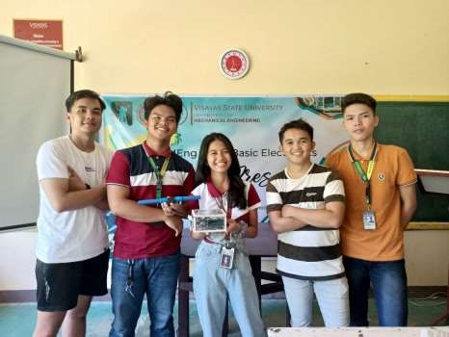

|  |
| --- |
|  |

* Project in Basic Electrical Engineering
* Miniature house with electric circuits

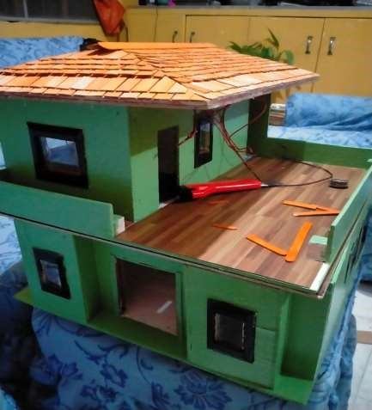

* Project in Workshop

- Barbeque grill

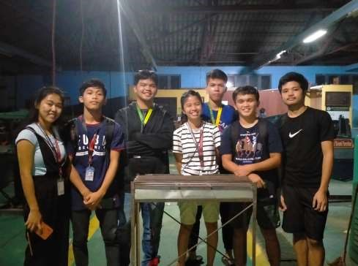

* Project in Machine Shop

- Trolley

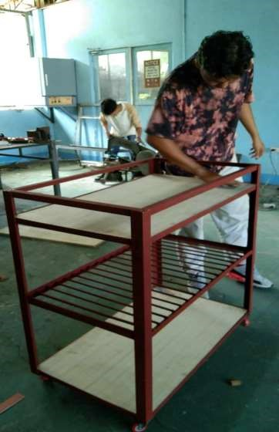

* Project in AC and DC
* DC Motor and DC Motor Trainer

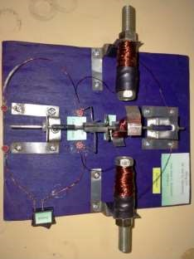

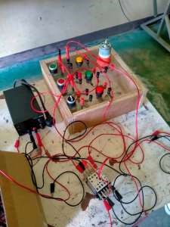

* Project in Dynamics of rigid bodies
* Slider Crank Mechanism

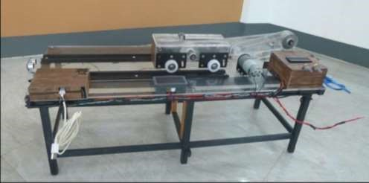

* Project in ME laboratory 1

